SQL ASSIGNMENT

1.Create A Table With Four Columns Of Your Choice, Making That They Have Null Constraints.

QUERY:

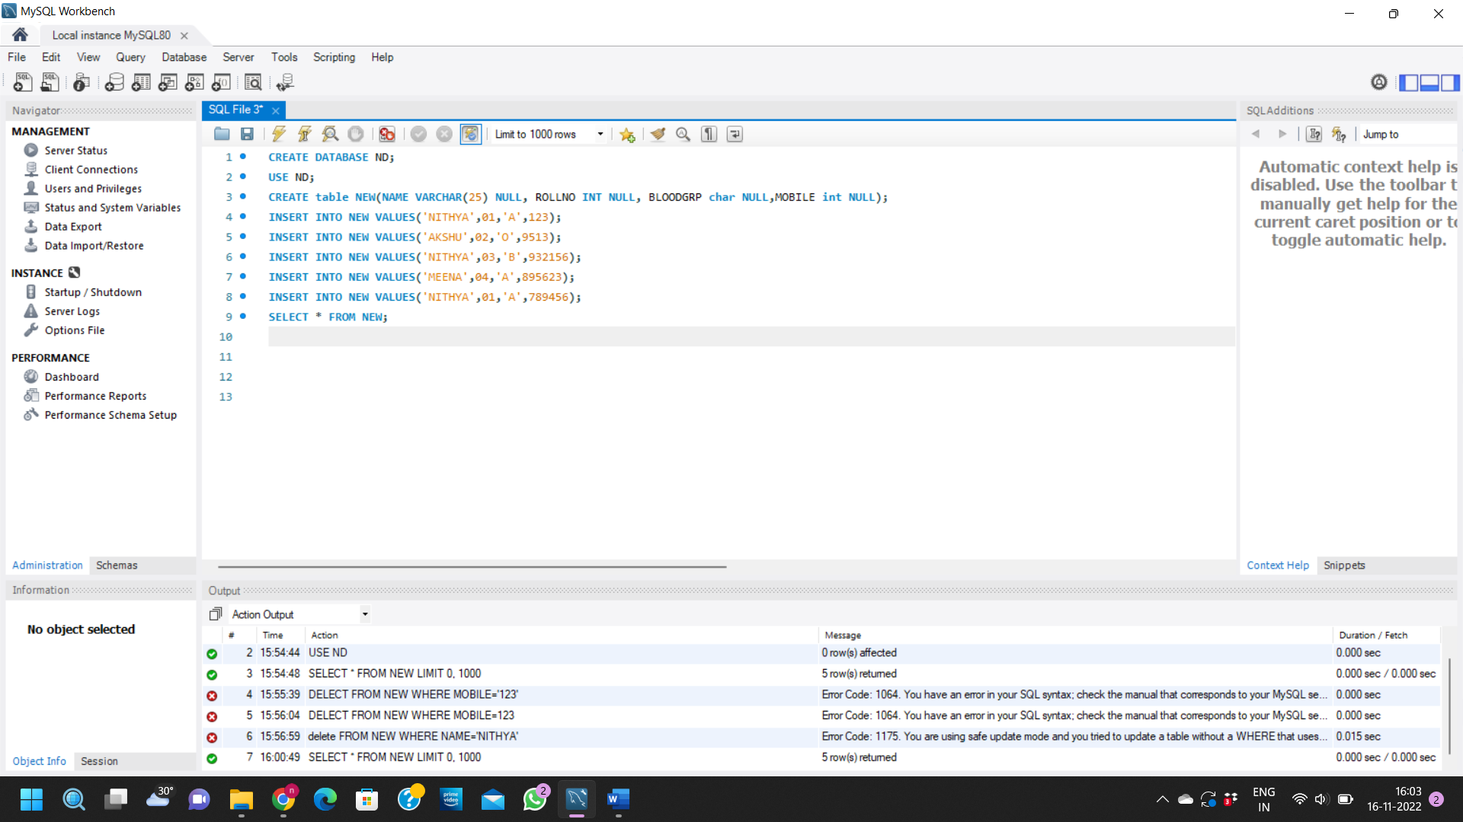

OUTPUT:

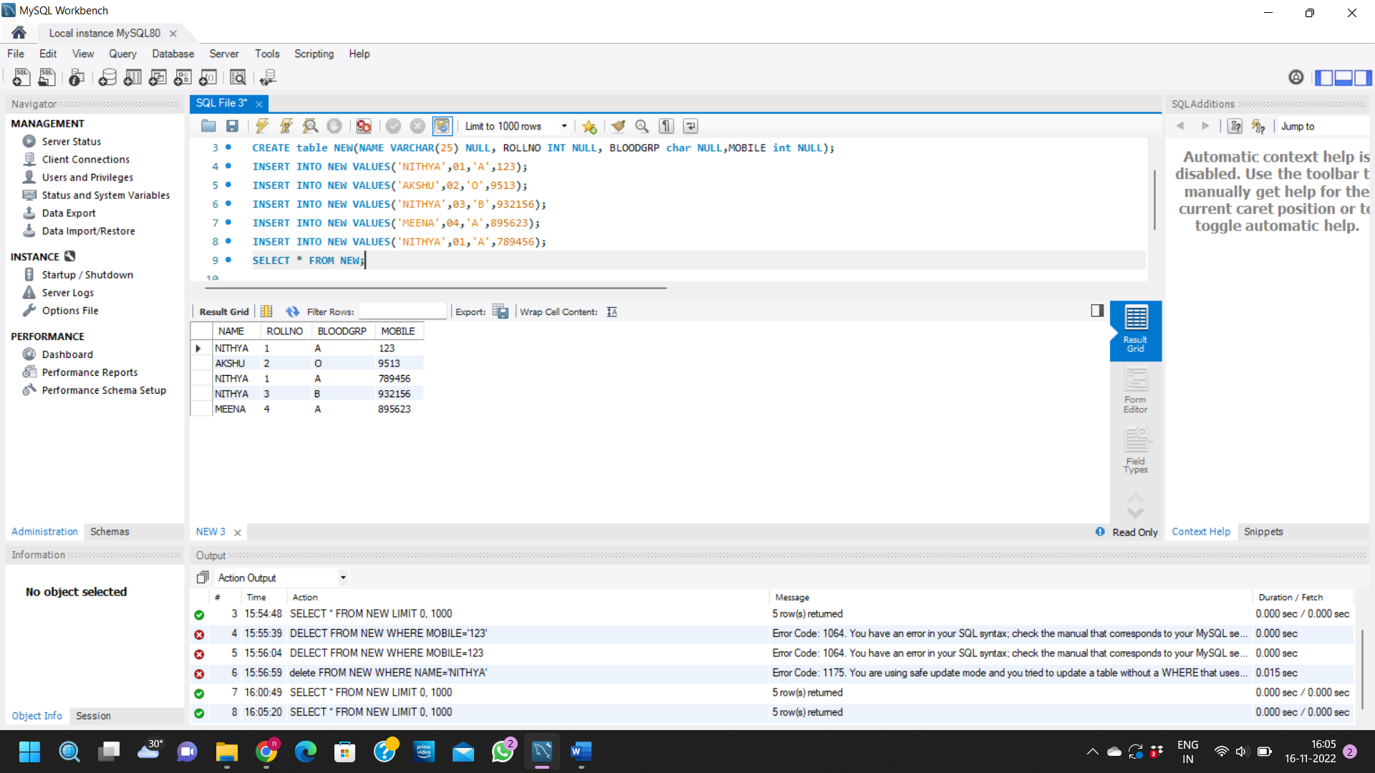

2. Create A Sales Table Having Columns ID, Product name, Price Per Unit And Quantity, and Then Create A View Which Will Show The Total Cost Per Each Product And Product Name

QUERY:

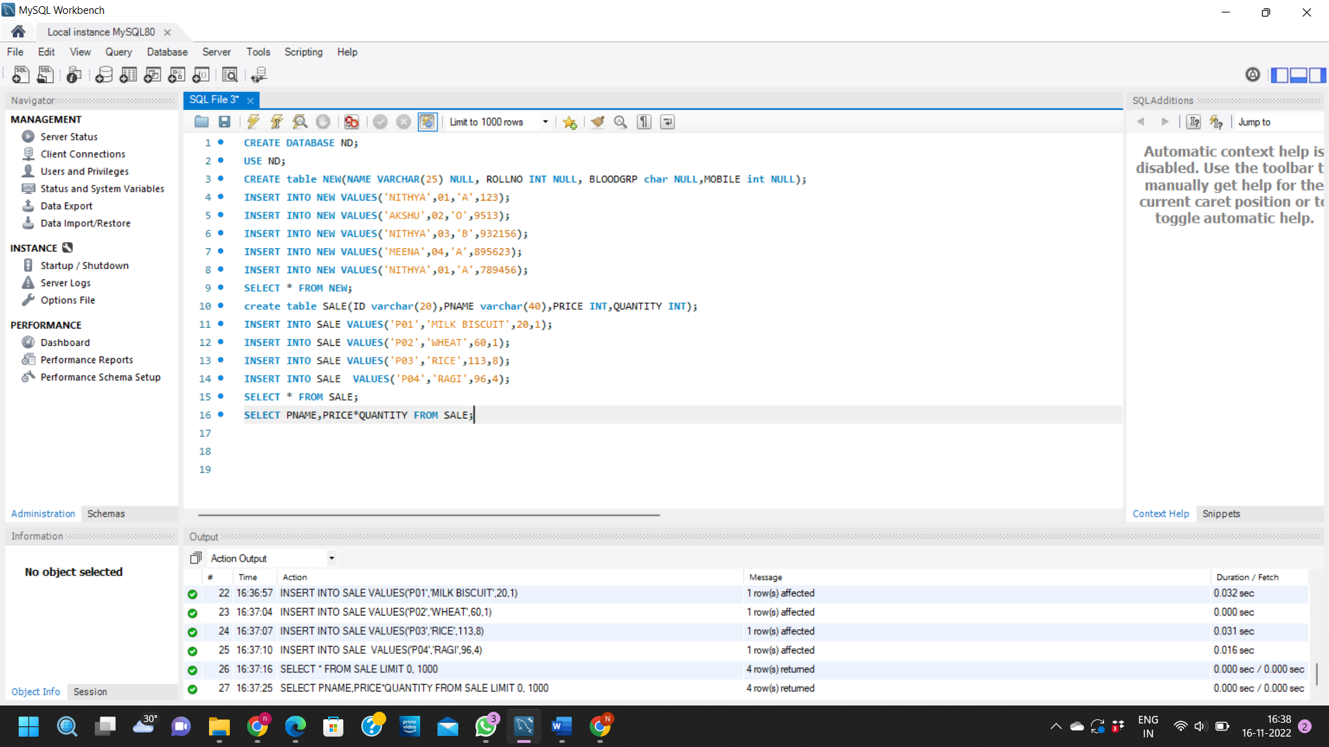

OUTPUT:

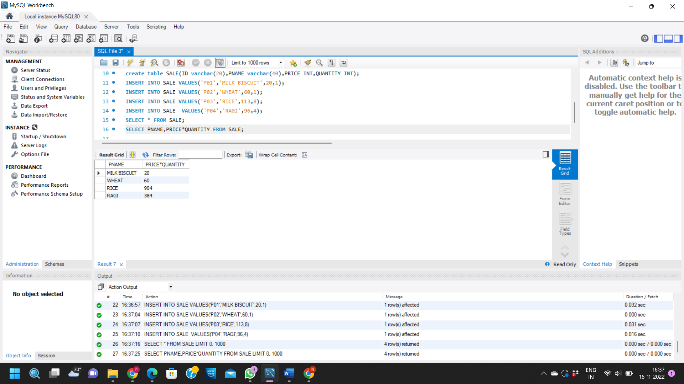

3.

ANSWER: SELECT SUM(AGE) FROM TABLENAME;

4.

ANSWER:SELECT \* FROM TABLENAME GROUPBY age,COUNT(age);

5.

ANSWER SELECT DIVISION,REVENUE FROM tablename WHERE REVENUE <0;